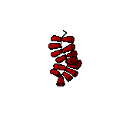

 |  | 1 |  | 16
 |  | 2 |  | 17
 |  | 3 |  | 18
 |  | 4 |  | 19
 |  | 5 |  | 20
 |  | 6 |  | 21
 |  | 7 |  | 22
 |  | 8 |  | 23
 |  | 9 |  | 24
 |  | 10 |  | 25
 |  | 11 |  | 26
 |  | 12 |  | 27
 |  | 13 |  | 28
 |  | 14 |  | 29
 |  | 15 |  | 30
 |  |  |  | 31

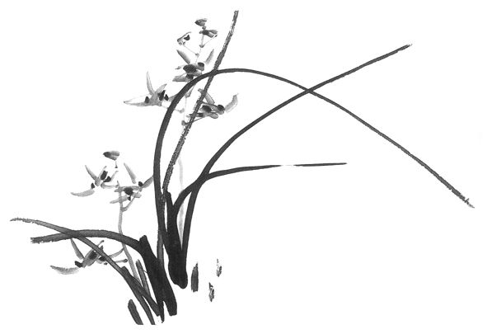

 |  | 1 |  | 16
 |  | 2 |  | 17
 |  | 3 |  | 18
 |  | 4 |  | 19
 |  | 5 |  | 20
 |  | 6 |  | 21
 |  | 7 |  | 22
 |  | 8 |  | 23
 |  | 9 |  | 24
 |  | 10 |  | 25
 |  | 11 |  | 26
 |  | 12 |  | 27
 |  | 13 |  | 28
 |  | 14 |  | 29
 |  | 15




 |  | 1 |  | 16
 |  | 2 |  | 17
 |  | 3 |  | 18
 |  | 4 |  | 19
 |  | 5 |  | 20
 |  | 6 |  | 21
 |  | 7 |  | 22
 |  | 8 |  | 23
 |  | 9 |  | 24
 |  | 10 |  | 25
 |  | 11 |  | 26
 |  | 12 |  | 27
 |  | 13 |  | 28
 |  | 14 |  | 29
 |  | 15 |  | 30
 |  |  |  | 31

 |  | 1 |  | 16
 |  | 2 |  | 17
 |  | 3 |  | 18
 |  | 4 |  | 19
 |  | 5 |  | 20
 |  | 6 |  | 21
 |  | 7 |  | 22
 |  | 8 |  | 23
 |  | 9 |  | 24
 |  | 10 |  | 25
 |  | 11 |  | 26
 |  | 12 |  | 27
 |  | 13 |  | 28
 |  | 14 |  | 29
 |  | 15 |  | 30

 |  | 1 |  | 16
 |  | 2 |  | 17
 |  | 3 |  | 18
 |  | 4 |  | 19
 |  | 5 |  | 20
 |  | 6 |  | 21
 |  | 7 |  | 22
 |  | 8 |  | 23
 |  | 9 |  | 24
 |  | 10 |  | 25
 |  | 11 |  | 26
 |  | 12 |  | 27
 |  | 13 |  | 28
 |  | 14 |  | 29
 |  | 15 |  | 30
 |  |  |  | 31




 |  | 1 |  | 16
 |  | 2 |  | 17
 |  | 3 |  | 18
 |  | 4 |  | 19
 |  | 5 |  | 20
 |  | 6 |  | 21
 |  | 7 |  | 22
 |  | 8 |  | 23
 |  | 9 |  | 24
 |  | 10 |  | 25
 |  | 11 |  | 26
 |  | 12 |  | 27
 |  | 13 |  | 28
 |  | 14 |  | 29
 |  | 15 |  | 30




 |  | 1 |  | 16
 |  | 2 |  | 17
 |  | 3 |  | 18
 |  | 4 |  | 19
 |  | 5 |  | 20
 |  | 6 |  | 21
 |  | 7 |  | 22
 |  | 8 |  | 23
 |  | 9 |  | 24
 |  | 10 |  | 25
 |  | 11 |  | 26
 |  | 12 |  | 27
 |  | 13 |  | 28
 |  | 14 |  | 29
 |  | 15 |  | 30
 |  |  |  | 31

 |  | 1 |  | 16
 |  | 2 |  | 17
 |  | 3 |  | 18
 |  | 4 |  | 19
 |  | 5 |  | 20
 |  | 6 |  | 21
 |  | 7 |  | 22
 |  | 8 |  | 23
 |  | 9 |  | 24
 |  | 10 |  | 25
 |  | 11 |  | 26
 |  | 12 |  | 27
 |  | 13 |  | 28
 |  | 14 |  | 29
 |  | 15 |  | 30
 |  |  |  | 31

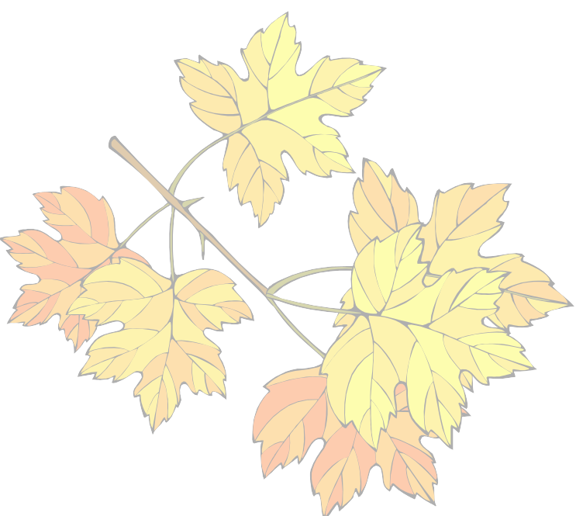

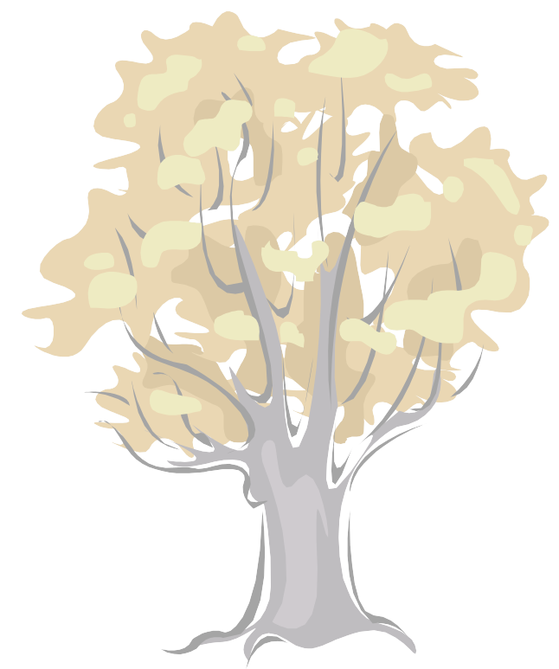

 |  | 1 |  | 16
 |  | 2 |  | 17
 |  | 3 |  | 18
 |  | 4 |  | 19
 |  | 5 |  | 20
 |  | 6 |  | 21
 |  | 7 |  | 22
 |  | 8 |  | 23
 |  | 9 |  | 24
 |  | 10 |  | 25
 |  | 11 |  | 26
 |  | 12 |  | 27
 |  | 13 |  | 28
 |  | 14 |  | 29
 |  | 15 |  | 30



 |  | 1 |  | 16
 |  | 2 |  | 17
 |  | 3 |  | 18
 |  | 4 |  | 19
 |  | 5 |  | 20
 |  | 6 |  | 21
 |  | 7 |  | 22
 |  | 8 |  | 23
 |  | 9 |  | 24
 |  | 10 |  | 25
 |  | 11 |  | 26
 |  | 12 |  | 27
 |  | 13 |  | 28
 |  | 14 |  | 29
 |  | 15 |  | 30
 |  |  |  | 31

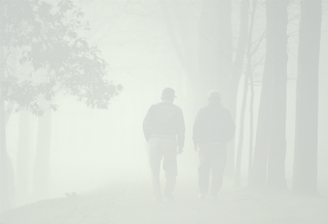



 |  | 1 |  | 16
 |  | 2 |  | 17
 |  | 3 |  | 18
 |  | 4 |  | 19
 |  | 5 |  | 20
 |  | 6 |  | 21
 |  | 7 |  | 22
 |  | 8 |  | 23
 |  | 9 |  | 24
 |  | 10 |  | 25
 |  | 11 |  | 26
 |  | 12 |  | 27
 |  | 13 |  | 28
 |  | 14 |  | 29
 |  | 15 |  | 30



 |  | 1 |  | 16
 |  | 2 |  | 17
 |  | 3 |  | 18
 |  | 4 |  | 19
 |  | 5 |  | 20
 |  | 6 |  | 21
 |  | 7 |  | 22
 |  | 8 |  | 23
 |  | 9 |  | 24
 |  | 10 |  | 25
 |  | 11 |  | 26
 |  | 12 |  | 27
 |  | 13 |  | 28
 |  | 14 |  | 29
 |  | 15 |  | 30
 |  |  |  | 31

